The following is a confidential questionnaire to determine the best possible treatment plan for you. Some of the questions may seem unrelated to your condition, but they play a major role in diagnosis and treatment. Please take your time in completing this as best as you can…Thankyou!

Name ___________________________________ Age __________ Date of Birth _____________ Sex: M F

Address ________________________________ City __________________ State ______ Zip Code ______________

Phone ____________________________ Marital Status: ________________ Number of children ____________

Employer ____________________________________ Occupation _____________________________

Address ________________________________ City __________________ State ______ Zip Code ______________

Email ____________________________________ Referred by? __________________________________________

Insurance

Medical Insurance? Yes No Relationship to insurer? Self Spouse Child Other

Name of Insured Person ____________________________________ Address __________________________________

City __________________ State ______ Zip Code ______________ Phone ___________________________________

Assignment and Release: I hereby authorize my insurance benefits be paid directly to the acupuncturist and I am financially responsible for non-covered services. I also authorize the acupuncturist to release any information required to process this claim.

Signed __________________________________________ Date _____________________________

Social Security Number __________________________ ID# _____________________ Group# _____________________

Insurance Company ___________________________________ Address ________________________________________

City __________________ State ______ Zip Code ______________ Phone ________________________________

Chief Complaint

Chief Complaint _______________________________________________________________________________________

Complaint the result of: Auto Accident Injury Job Related Other _________________

Date of accident, injury, other _____________________________________________________________________________

Have you seen any other medical professional about this condition? ____________ If yes, when? ________________________

Doctor’s name ___________________________________ Address ______________________________________________

In case of emergency, call _________________________________________________________________________________

How long have you had this condition? _____________ Have you had this in the past? __________ If yes, when? _________

What makes it better? ___________________________ What makes it worse? ______________________________________

Is your condition: Getting worse Constant Comes and Goes

Other complaints _______________________________________________________________________________________

Medications & Supplements: Check the box next to any of the following that you are now taking.
Antacids Allergy medication Steroids
Aspirin Ibuprofen/Advil/Tylenol Tranquilizers/Sleeping pills
Cold tablets Laxatives Herbs
Diet pills Oral Contraceptives Vitamins
Diuretics Blood pressure medication Antidepressants
Interferon Antibiotics Hormone replacement therapy
Viagra DHEA/Melatonin/ Beta HCG Coumadin/Warfarin

Please list the names of medications you are currently taking: ____________________________________________________
_____________________________________________________________________________________________________

Please list any medication allergies you have: ____________________________________ _____________________________ _____________________________________________________________________________________________________

Habits: Please mark any of the habits listed below which apply to you. Mark “X” for current habits.
Mark “✓” for past habits.

Use of tobacco: Yes No If yes, # of cigarettes/day _________ age started______

Use of alcohol: Yes No If yes, # of drinks per week _______ age started______

Use of Caffeine: Yes No # sodas / day____ # coffee / day ____ # tea / day____

Family Medical History: Check “✓” all that apply.
 | You | Relative | Date |  | You | Relative | Date
Cancer |  |  |  | Rheumatic Fever
Hepatitis |  |  |  | Infectious Diseases
High Blood Pressure |  |  |  | Diabetes
Stroke |  |  |  | Heart Disease
Neurological Disease |  |  |  | Seizures
Thyroid Disease |  |  |  | Emotional Disorders
Alzheimer’s |  |  |  | Tuberculosis
Gall Bladder Disease |  |  |  | Other:

Personal History: Check “✓” all that apply.

General
____ Anemia ____ Mumps ____ Herpes ____ Chronic Fatigue Syndrome
____ HIV ____ Measles ____ Eating Disorders ____ Fibromyalgia
____ Multiple Sclerosis ____ Chicken Pox ____ Jaundice ____ Irritable Bowel Syndrome

Cardiovascular
____ High blood pressure ____ Dizziness ____ Chest pain ____ Cold hands/feet
____ Low blood pressure ____ Fainting ____ Irregular heartbeat ____ Swelling in hands/feet
____ Blood clots ____ Phlebitis ____ Palpitations ____ Other

Respiratory
____ Cough ____ Asthma ____ Hay fever ____ Production of Phlegm
____ Pneumonia ____ Difficulty Breathing ____ Tight chest What color _____________
____ Bronchitis ____ Difficulty breathing lying down ____ Coughing blood

Gastrointestinal
____ Nausea ____ Gas ____ Black Stools Bowel Movements:
____ Vomiting ____ Belching ____ Pain or Cramps Frequency ____
____ Bad Breath ____ Rectal Bleeding ____ Sensitive abdomen Color _________________
____ Constipation ____ Bloody Stools ____ Gastritis Odor _________________
____ Diarrhea ____ Hemorrhoids ____ Peptic Ulcers Texture/form ___________
____ Heartburn ____ Feeling of immovable foreign object

Genito-Urinary
____ Pain on urination ____ Frequent urination ____ Blood in urine ____ Wake up to urinate
____ Incontinence ____ Kidney stones ____ Venereal disease How often _______/night
____ Urgency to urinate ____ Impotency

Neuropsychological
____ Seizures ____ Areas of numbness ____ Poor memory ____ Concussion
____ Depression ____ Anxiety ____ Bad temper ____ Easily stressed
Treated for emotional problems? __________________ Other neurological or psychological problems? ___________________

Skin and Hair
____ Rashes ____ Ulcerations ____ Hives ____ Itching
____ Eczema ____ Pimples ____ Dandruff ____ Loss of hair
____ Change in hair/skin texture ____ Purpura ____ Other hair or skin problems _________________

Head, Eyes, Ears, Nose and Throat
____ Grinding teeth ____ Recurrent sore throats ____ Facial pain ____ Eye Strain
____ Teeth problems ____ Sores on lips or tongue ____ Poor hearing ____ Night blindness
____ Jaw clicks ____ Sinus problems ____ Ringing in Ears ____ Glasses
____ Dry mouth ____ Nose bleeds ____ Earaches ____ Eye pain
____ Dry throat ____ Mucus ____ Blurry vision ____ Poor vision
____ Copious saliva ____ Dizziness ____ Cataracts ____ Glaucoma
____ Gum problems ____ Migraines ____ Spots in eyes ____ Macular Degeneration
Other head or neck problems ___________________________ Wet or Dry type? ________

Sleep
____ Cannot fall asleep ____ Excessive sleep ____ Lots of dreams ____ Wake up easily
____ Wake up too early ____ Snoring ____ Tired upon waking, not refreshed
____ Tossing and turning during sleep ____ Cannot get back to sleep after waking

Appetite
____ Large ____ Average ____ None How many snacks between meals? ____

Temperature
____ Feeling of heat, where? ___________________

____ Feeling of coldness, where? ________________ ____ Alternating chills and feverishness

Sweat
____ Easily perspires ____ Rarely perspires ____ Sweating during sleep

Diet
____ Prefer sweet ____ Prefer salty ____ Prefer oily food ____ Prefer meat
____ Prefer vegetables ____ Prefer fruit ____ Prefer junk food

Major Hospitalizations
If you have ever been hospitalized for any serious medical illness or surgery, write in your most recent hospitalizations below. Check this box if you have had more than three such hospitalizations. (Do not include normal pregnancies).

Last Hospitalization_____________________________________________________________________________
Year Operation/Illness Hospital/City/State

Previous Hospitalization _________________________________________________________________________
Year Operation/Illness Hospital/City/State

Previous Hospitalization _________________________________________________________________________
Year Operation/Illness Hospital/City/State

Jamie Lee Tokubo’s office has a 24 hour cancellation policy in order to not be charged the full price of an acupuncture visit. Of course in the case of an emergency there will be no penalty upon the patient for missing the visit. Please sign and date that you have read this policy and agree to the terms. X____________________________________

HIPPA Compliance Requirement
Patient Consent to the Use / Disclosure of Patient History Information
for Treatment, Payment or Healthcare Operations

I, ___________________________________________, understand that as part of my health care, _______________________, L. Ac. originates and maintains paper and/or electronic records describing my health history, symptoms, examination and test results, diagnoses, treatment and any plans for future care or treatment. I understand that this information serves as:
A basis for planning my care and treatment,
A means of communication among the health professionals who contribute to my care,
A source of information for applying my diagnosis and treatment to my bill,
A means by which a third party payer can verify services billed were actually provided,
A tool for routine healthcare operations such as assessing quality and reviewing the competence of healthcare
professionals.
I understand that as part of this organization’s treatment, payment or healthcare operations, it may become necessary to disclose my protected health information to another entity and I consent to such disclosure for these permitted uses, including disclosures via fax. A copy of the Notice of Information Practices is available upon request.

___________________________________________ _________________________
Patient’s Signature Date

On occasion, _______________________, L. Ac. may have confidential health information about you, such as laboratory results which we may wish to convey to you by telephone. Please indicate how you want us to handle this:

Write only, do not call Call this number: ________________ My confidential information may be
discussed with the following people.

PAIN
Mark the areas of pain.
Describe the location:__________________________________________________________
____________________________________________________________________________
Quality of pain: (circle) dull sharp stabbing sore cramping throbbing
burning constant radiating fixed moves about severe moderate

Rate the intensity of the pain. (circle)
(1 = A mild headache) (10 = Kidney stones or giving birth)

1 2 3 4 5 6 7 8 9 10

Where does the pain radiates to:___________________________________________________
Describe the onset of the pain:_____________________________________________________
_____________________________________________________________________________

What relieves the pain? (circle) ice heat rest movement a.m.
p.m. dampness dry
What aggravates it? (circle): ice heat rest movement a.m.
p.m. dampness dry

Is there any stiffness? Where? ______________________________________________________
______________________________________________________________________________
Are there any movements that aggravate the pain? ______________________________________
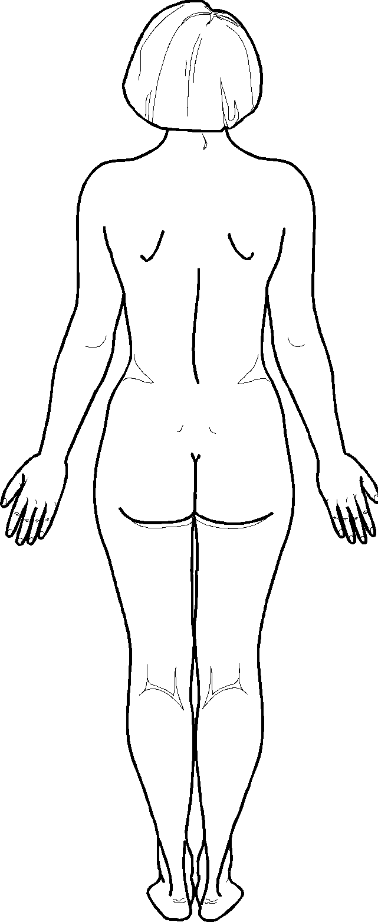
_______________________________________________________________________________
How does exercise effect your pain? __________________________________________________
What does the pain prevent you from doing? __________________________________________
______________________________________________________________________________
Do any medications help your pain? _________________________________________________
What other treatments have you had for the pain? ______________________________________
_______________________________________________________________________________

Diagnostic tests done:
Blood work ___ when?_________ results______________________________________________
X-ray ___ when?_________ results____________________________________________________
MRI ___ when?_________ results_____________________________________________________
CT scan ___ when?_________ results__________________________________________________
EMG___ when?_________ results____________________________________________________

Any surgeries related to the pain? _____________________________________________________

For Women
Age of 1st period (menarche) ___________ | Are you pregnant? Yes No | Last Exam Dates and Results | Have you been diagnosed with:
Age of last period (menopause) ___________ | # of pregnancies _________ | Gynecologic exam ________ | Fibroids? Yes No
 | # of live births __________ | Pap smear ____________ | Fibrocystic breasts? Yes No
Number of days between periods ____________ | # of abortions __________ | Mammogram ____________ | Endometriosis? Yes No
Number of days of flow ____________ | # of miscarriages _________ | Bone density scan ________ | Ovarian cysts? Yes No
Color of flow __________ | Do you use an IUD? |  | Pelvic Inflammatory Disease? Yes No
Clots? Yes No | Yes No |  | Other _________________
 | Pain at Menses (Circle) | Location: Lower abdomen, Lower back, Thighs, Other _____
Size of clots ___________ | Cramping – before, during or after | Stabbing – before, during or after | Burning – before, during or after
Average number of pads you use per day _____________ | Dull – before, during or after | Bloating – before, during or after | Consistent – before, during or after
 |  | Bearing down sensation – before, during or after | Intermittent – before, during or after
Discharge -  thick, thin, watery? | Other symptoms related to menses |  | Check “✓” all that apply:
Color? _______________ | ____Vaginal dryness | ____ Nausea | ____ Headache
 | ____ Swollen breasts | ____ Poor appetite | ____ Ravenous appetite
Odor? _______________ | ____ Hot flashes | ____ Night sweats | ____ Insomnia
 | ____ Vaginal itching or sores | ____ Decreased libido | ____ Increased libido
When? ______________ | ____ Vaginal infections

Headaches

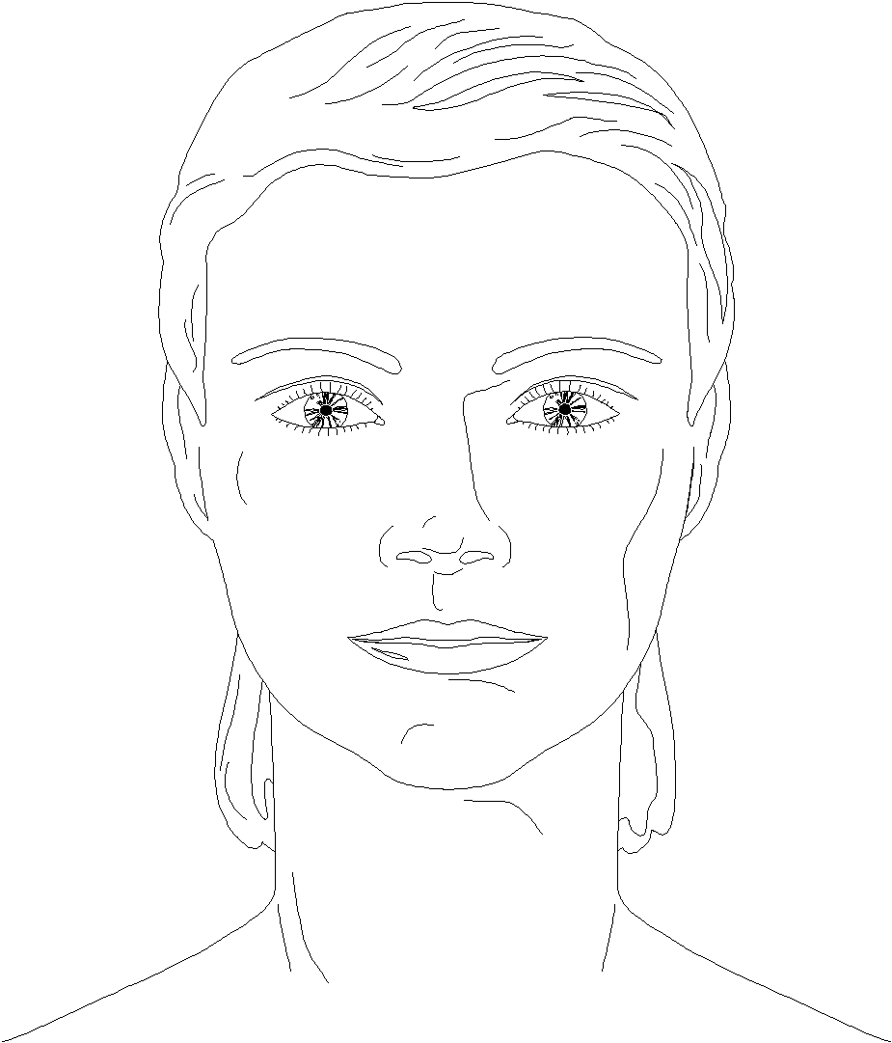
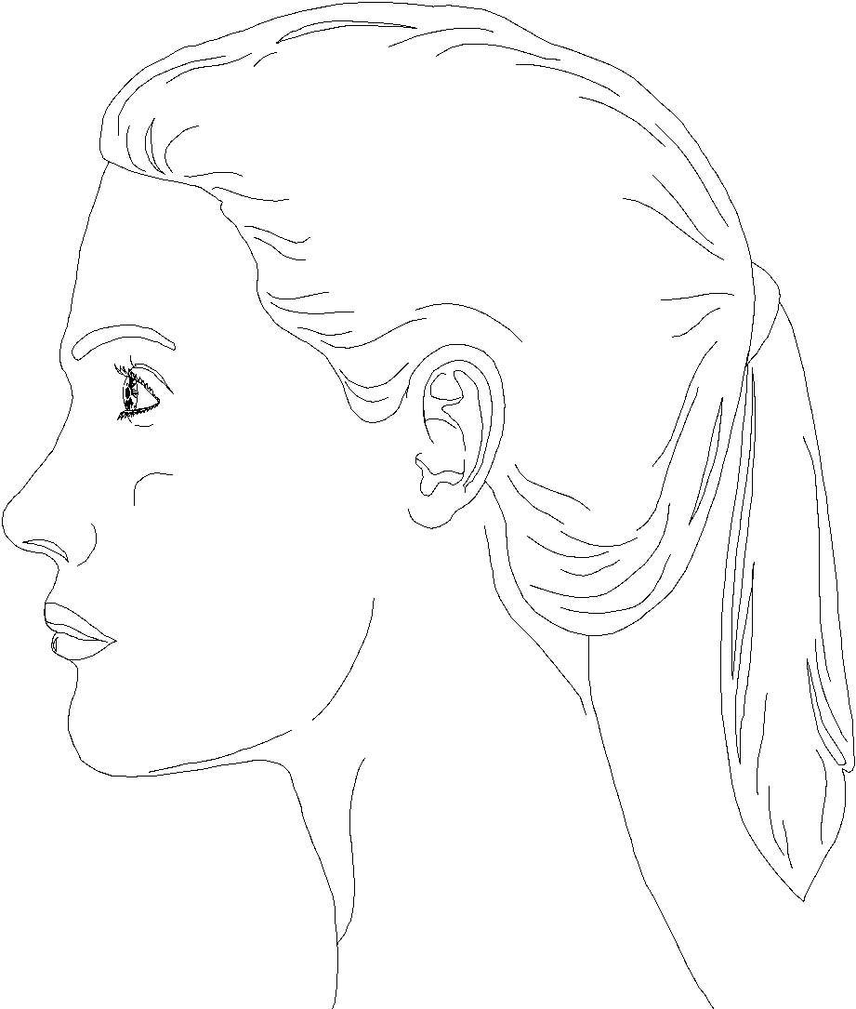
Where do you get headaches? Mark on the images.

How often do you get headaches? __________________

Describe the type of pain: (circle)
Burning Dull Consistent Stabbing Aching Intermittent

What makes the pain better? ____________________________________________________________________________

What makes it worse? __________________________________________________________________________________

Do you get headaches before, during or after your period? ______________________________________________________

For Men
Date of last prostate check up _______ | Frequency of Urination
PSA results _____________________ | Daytime ________________________
Manual Prostate Exam results _______ | Nighttime _______________________
Lab results _____________________ | Color of Urine ___________________
Symptoms related to prostate: | Check “✓” all that apply: | Other ___________________
____ Delayed Stream | ____ Dribbling | ____ Increased Libido
____ Incontinence | ____ Retention of Urine | ____ Decreased Libido
____ Rectal Dysfunction | ____ Impotence | ____ Groin Pain
____ Back Pain | ____ Premature Ejaculation | ____ Testicular Pain

Headaches
Where do you get headaches? Mark on the images.

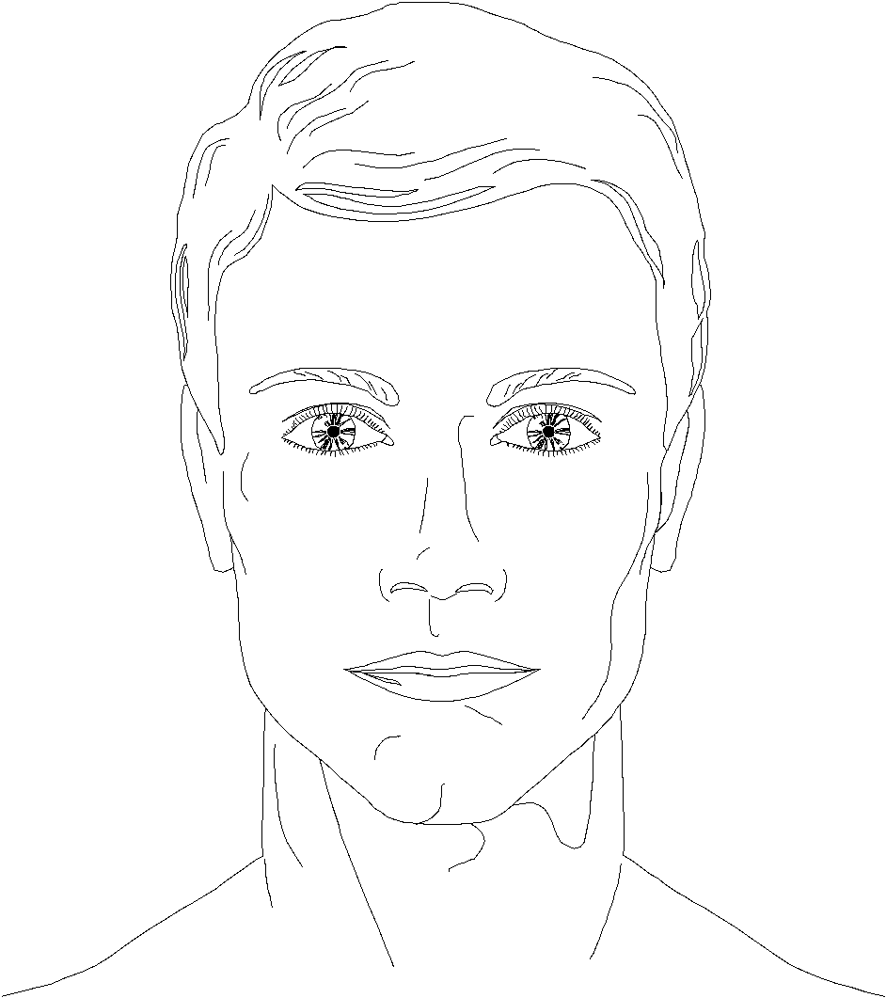
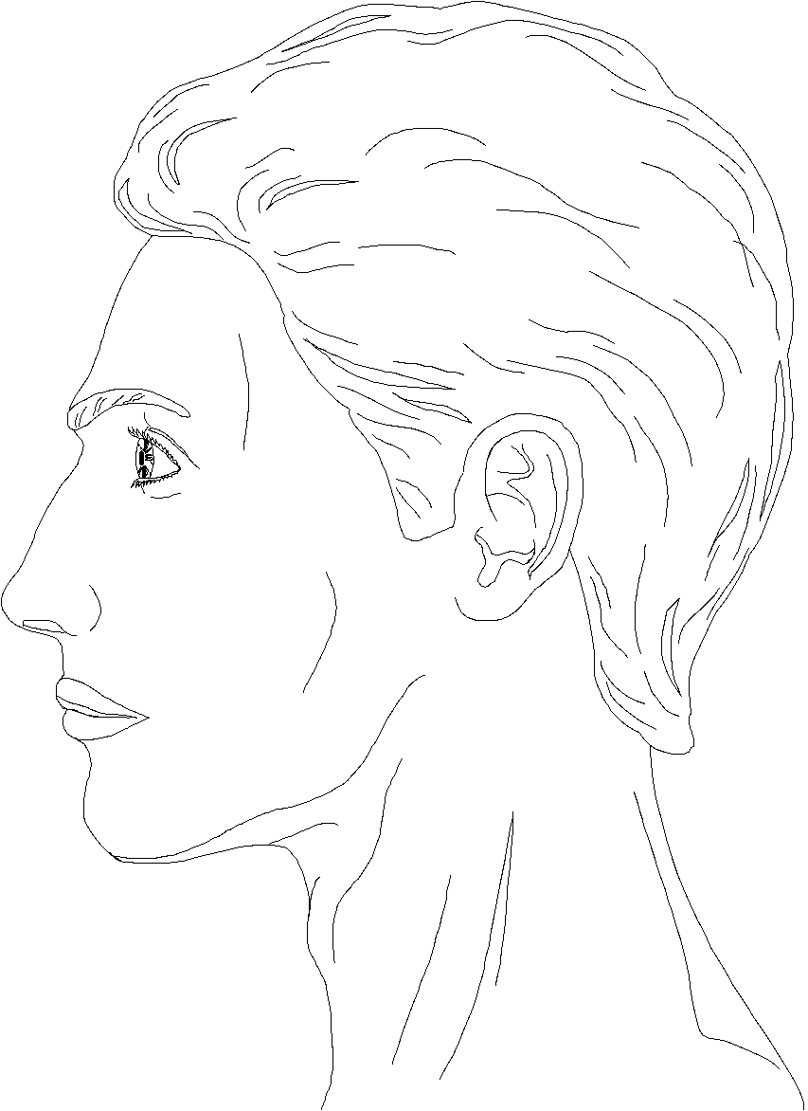
How often do you get headaches? ____________________

Describe the type of pain: (circle)
Burning Dull Consistent Stabbing
Aching Intermittent

What makes the pain better? _____________________________________________________________________________

What makes it worse? ___________________________________________________________________________________

